Search for Vertex AI in GCP and select Workbench as shown below, click create new workbench
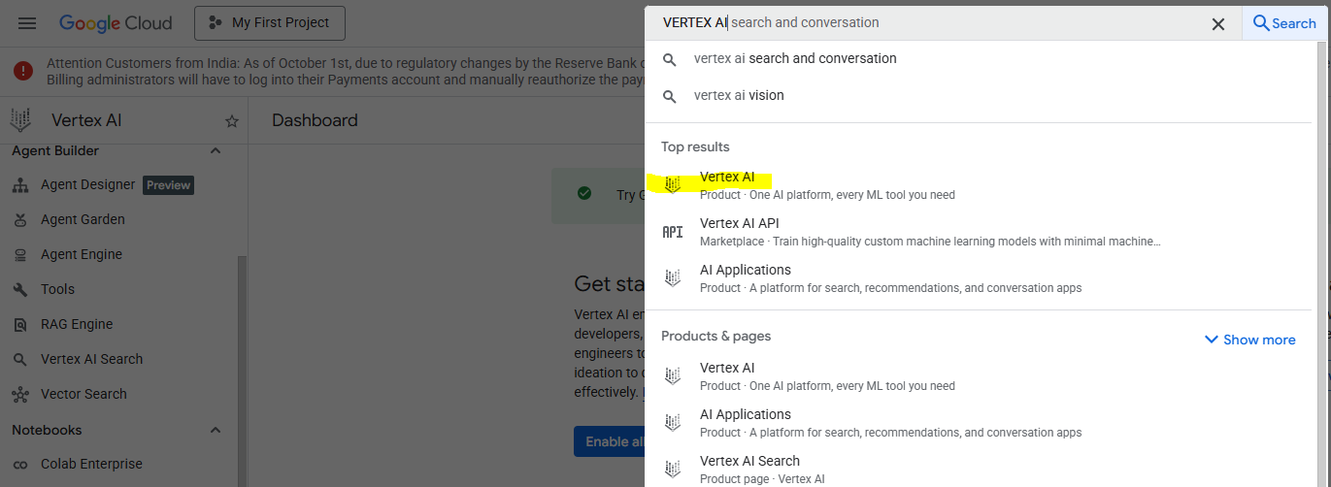
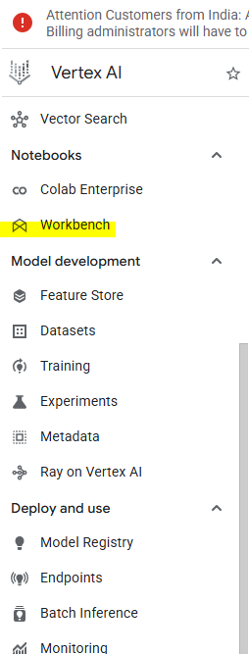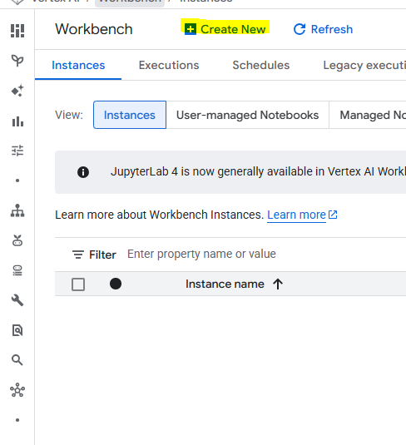
Uncheck ‘Enable Apache Spark and Big Query Kernels’ and Create Instance
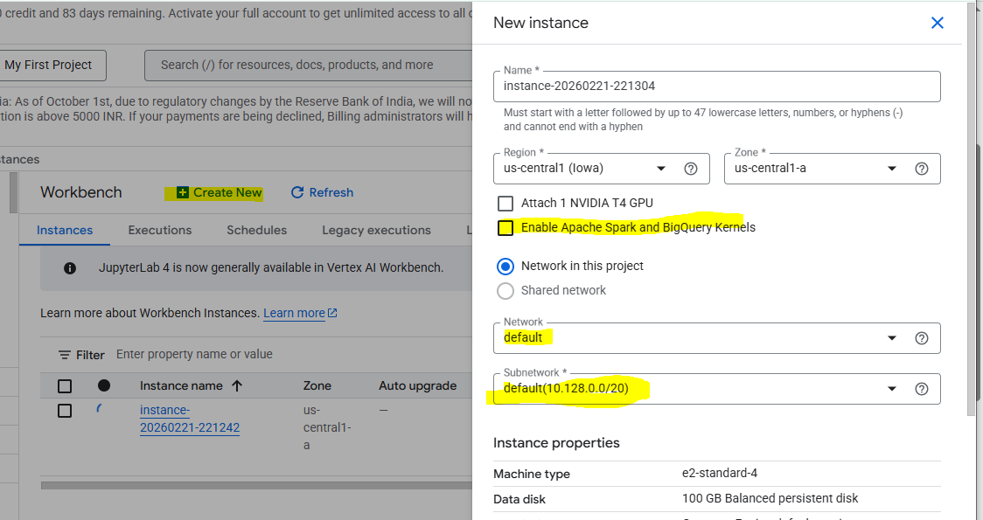

After Successful creation of instance click on ‘Open Jupyter Lab’
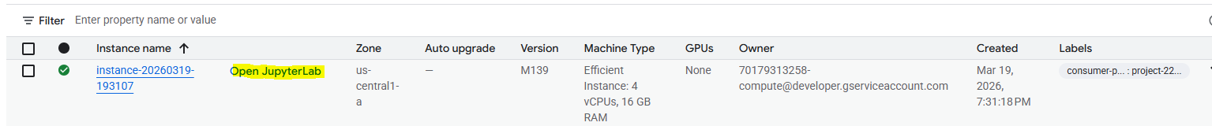
By Clicking the upload icon upload the local Enterprise RAG folder which is downloaded from GIT Hub(From Srini)

Again, go back to GCP Home and search for GCS(Cloud Storage)

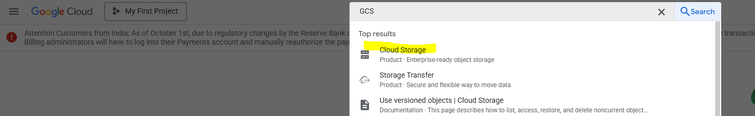

Create bucket with new folder aib_raw_pdfs
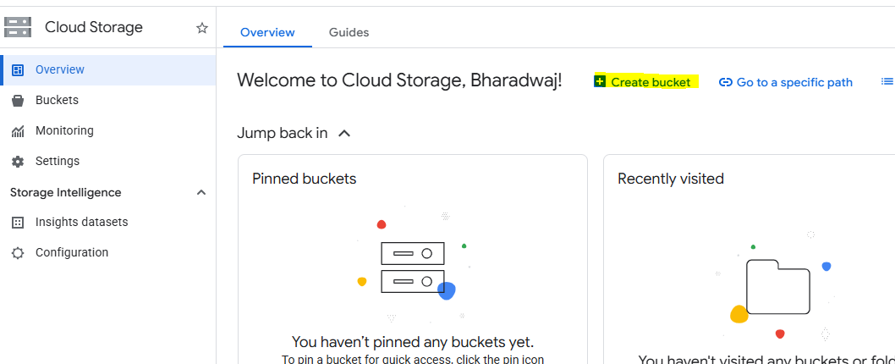
Give the unique name and create
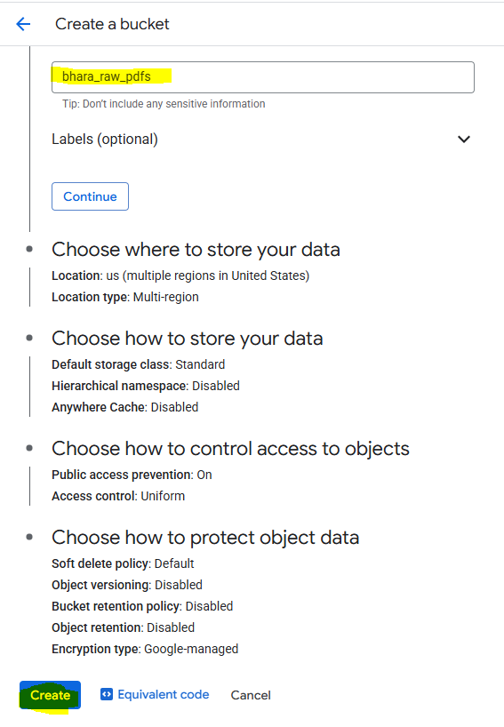
Inside bhara_raw_pdfs create sub folder with pdfs and upload the pdf from local
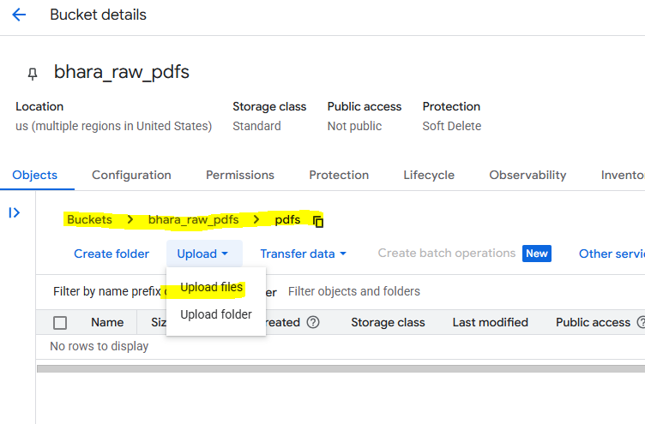
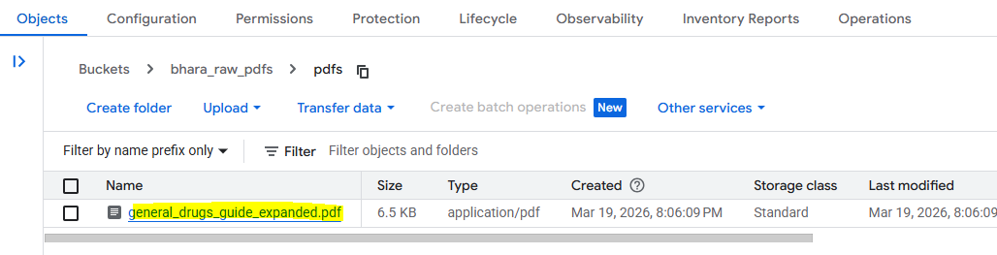

Again, go to GCP home and search for Vector Search
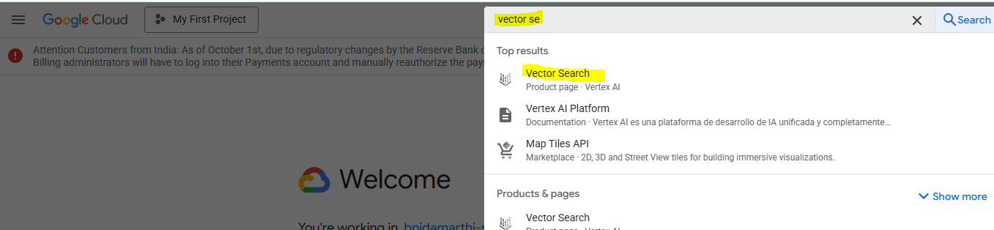
Note: As of now No action required with Vector search
Launch the Jupyter lab from Workbench and change the config file project and GCS bucket values with you respective values.

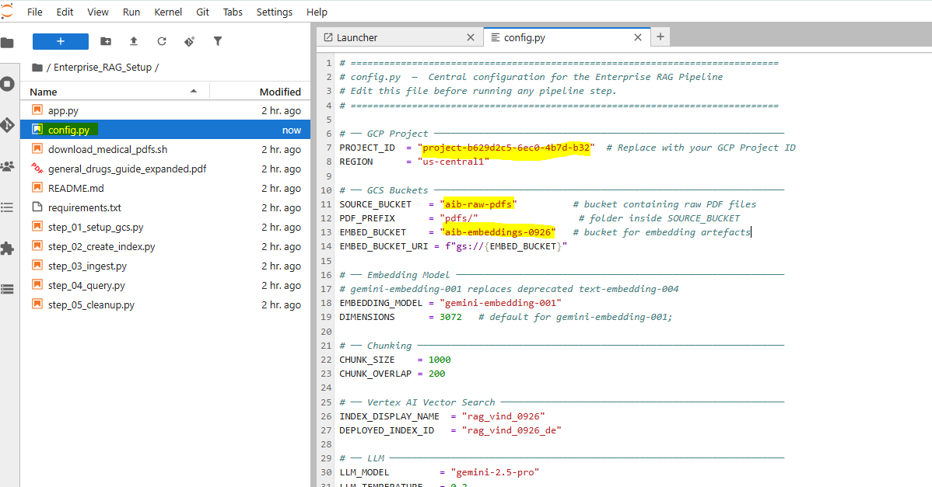

Important Note: Please make sure the below highlighted values should be unique for every one with your own parameters
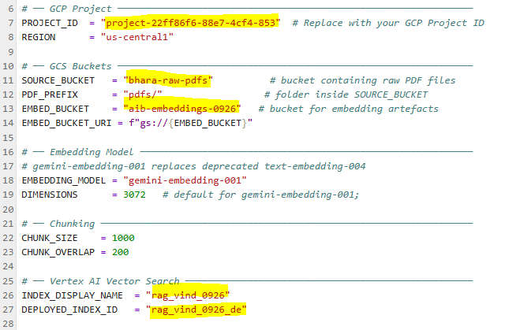
Open terminal:
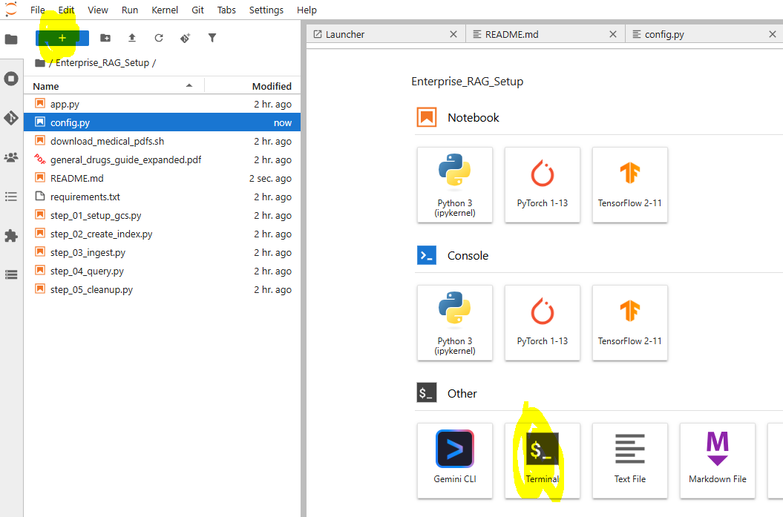
Run the below commands to make sure all the fails in your directory along with your .env
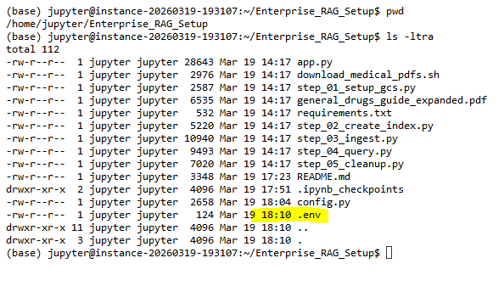
Create GCS buckets by running the below command in terminal
```bash python step_01_setup_gcs.py```
Creates `SOURCE_BUCKET` (for raw PDFs) and `EMBED_BUCKET` (for embeddings).
***** If you are facing any error as below, please follow the below instructions ****
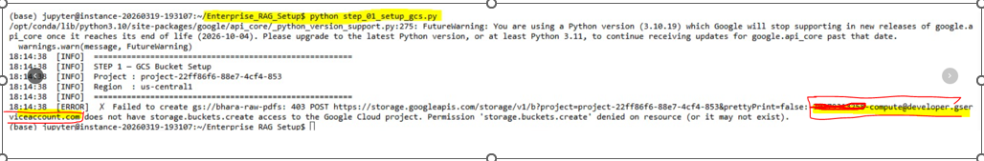
- Copy your service account highlighted in red above
- Search for IAM in homepage search bar
- Follow the below steps to add below roles one by one
- Vertex AI Administrator &
- Storage Admin
- Storage Object user
- Storage Object Admin
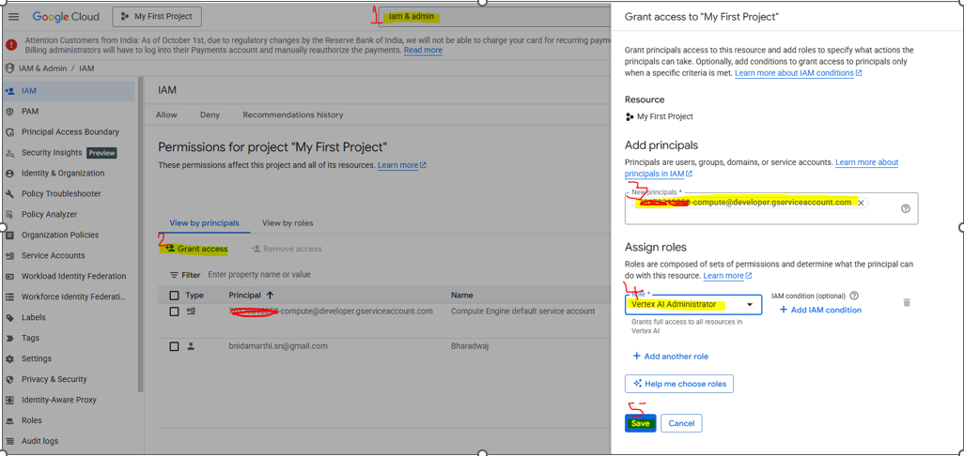

**************************End *********************************

Now, lets run the same below command in terminal
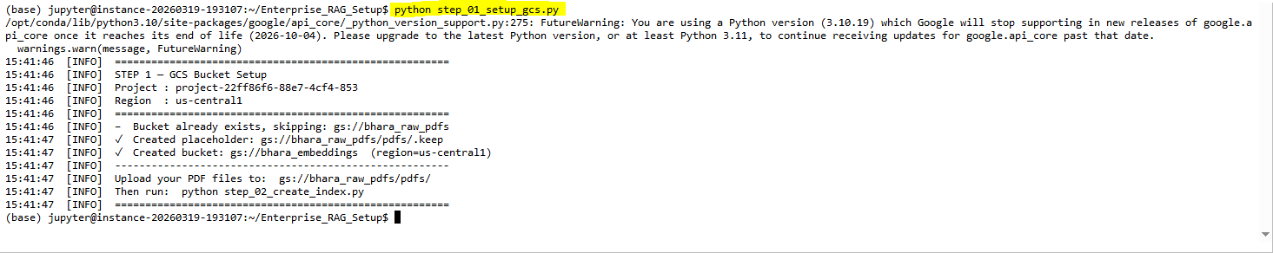
You can confirm by checking the folders created in GCS
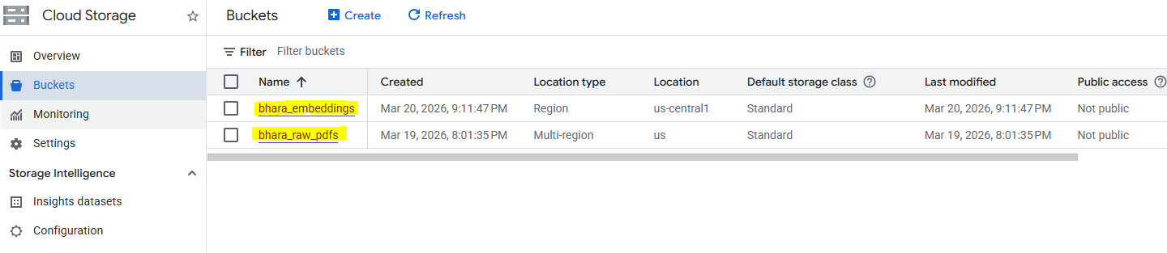

Next Run this command in terminal to upload your pdf from source bucket

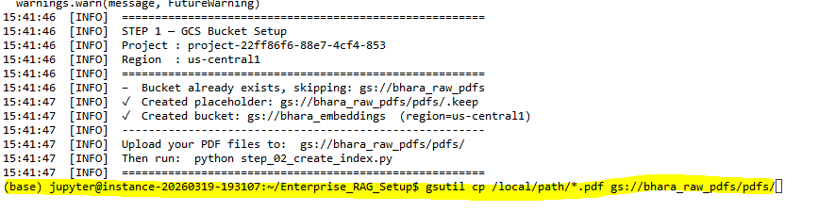
gsutil cp /home/jupyter/Enterprise_RAG_Setup/general_drugs_guide_expanded.pdf gs://bhara_raw_pdfs/pdfs/
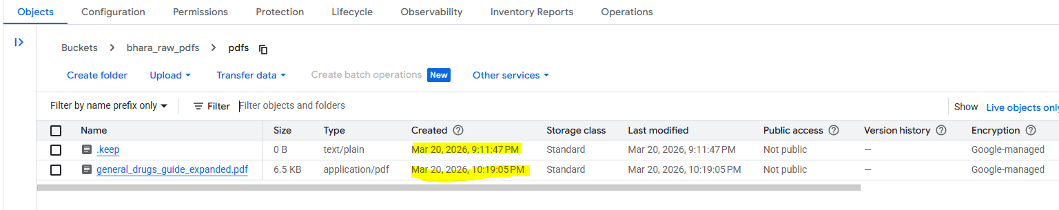

Next run the below command
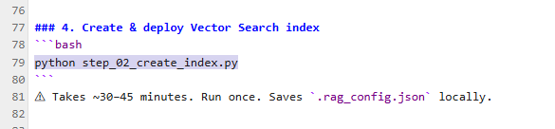
You can see the indexes in Vector search
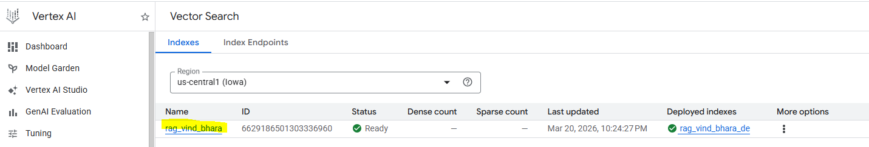

Ingest Documents:
Run below command in Terminal
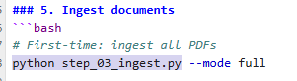
While running the ingest command, if you are facing below error. Please install requirements.txt

Note: Make sure first two lines are commented in side requirements.txt
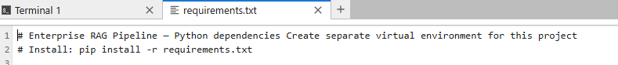
Then again run python step_03_ingest.py successfully
After ingest below folders should be created under embeddings folder in GCS
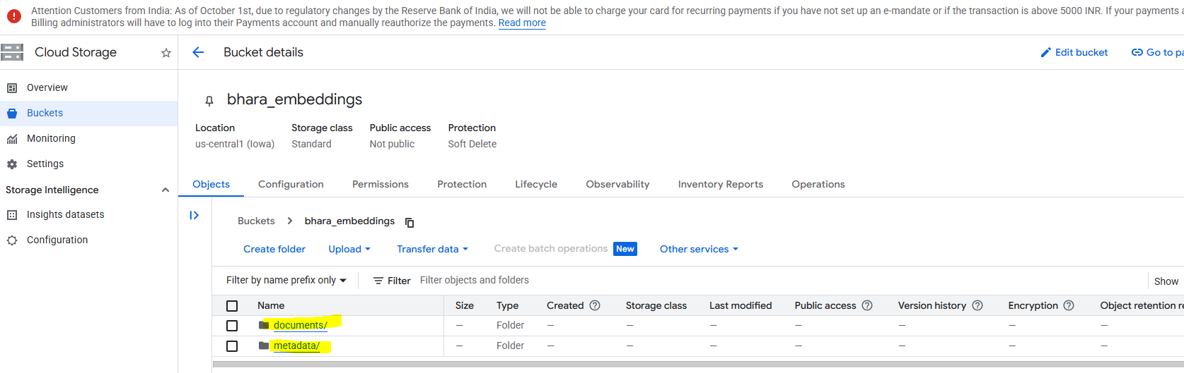
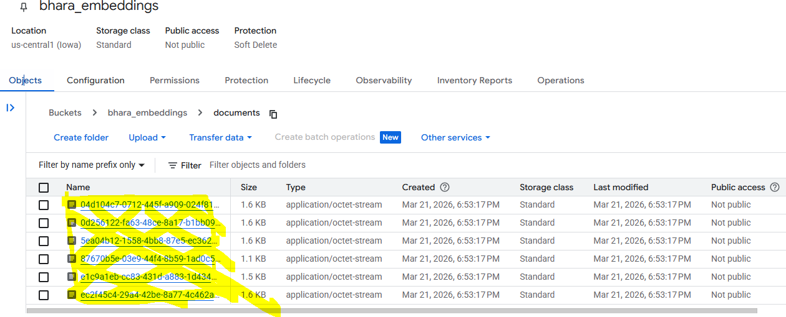
To test the query in terminal, please run the below command for testing the LLM for response as below.

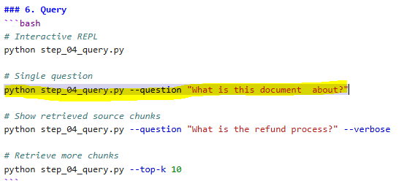
If you faced any issue with below reason, We need to open Step_03_ingest.py and setup_04_query.py and update with same dimensions 3072 on both the files.

Once corrected the dimensions again run the below query and verify the response as below
python step_04_query.py --question "What is this document about?"
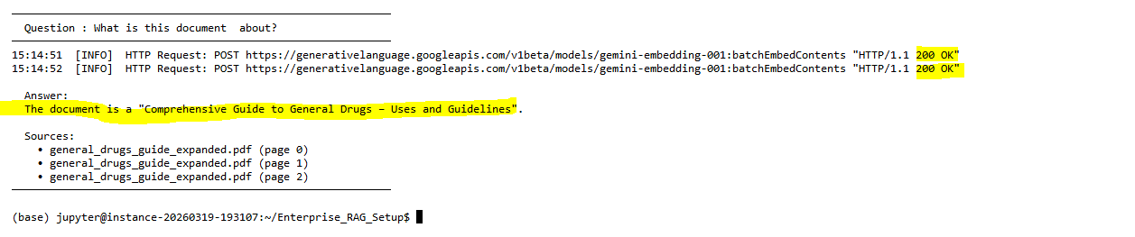

*********************** The End **********************

